Path to Enlightenment

•18th century philosophical movement by those greatly impressed with the scientific revolution
– Use systematic logic and reason to solve the problems of humankind
• Believed ___________________________________________________________________________
___________________________________________________________________________________.
– Commitment to reason
– Trust in modern sciences to solve problems
– Commitment to the idea of progress
– Belief in the essential goodness of human nature
– Emphasis upon the individual as master of his fate and fortune
– Engagement with the public in discussion and action

John Locke
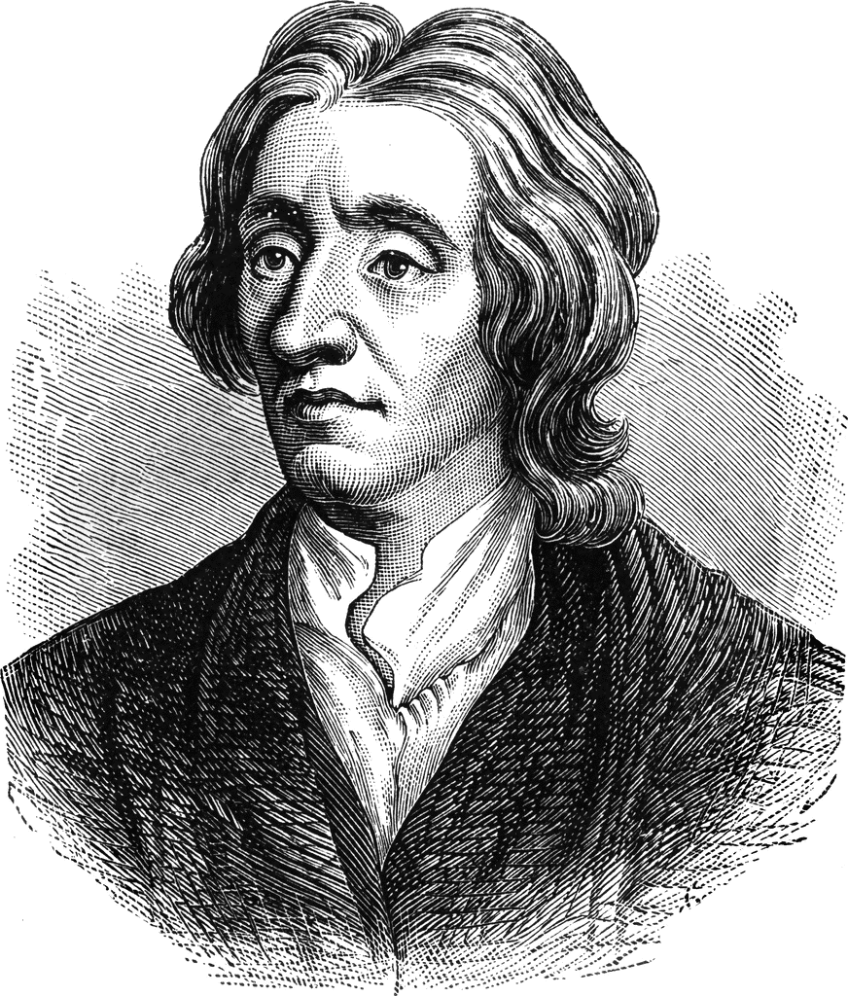
• Philosophe - ___________________________________.
• Argued that every person was born with a blank mind – ____________________
• People shaped by experiences in the surrounding world
– Change the environment, change the people?
• Human _______________________________________________________
• Virtue can be learned and practiced
• The individual must become a “rational creature”
• _______________________________ is ridiculous - contract with the people

Isaac Newton’s Impact
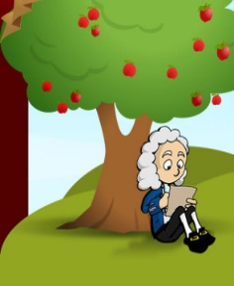
• World __________________________________________________________________________
– Natural laws can be uncovered through systematic investigation
• Enlightenment believed ____________________________________________________________
_________________________________________________________________________________
– Create an ideal society?

Montesquieu
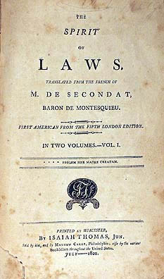
• Charles-Louis de Secondat, Baron de Montesquieu
• ___________________________________ (1748)
– Study of governments using the scientific method
– Discover natural laws of social and political relationships
– Identified three basic types of government:
• Republics – small states
• Monarchy – moderate-sized states
• Despotism – large states
– Identifies ________________________________________________________
• Limit any one part of government from growing too strong

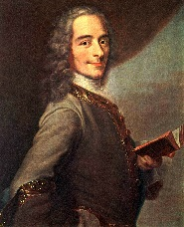
Voltaire

• Criticized Christianity
• ______________________________________________________ (Treatise on Toleration, 1763)
• Deism – ________________________________________________________________________
________________________________________________________________________________
– Created it, set it in motion and allowed it to run without interference and according to its
own natural Laws

Denis Diderot

• Created the ____________________________
–______ volume collection of knowledge
– Many articles attacked religious superstition and supported religious toleration
– Called for social, legal and political reform –Spread many Enlightenment ideas

Adam Smith & Economics

• If individuals are free to pursue their own economic self-interest, ___________________________
•____________________ should allow the free play of ____________________________________
• _____________________________, 1776
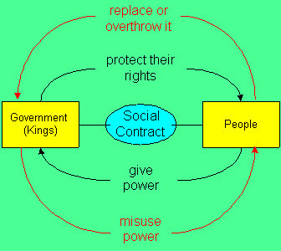
– Government should:
1. Protect society from invasion
2. Defend citizens from injustice
3. Maintain public works too expensive for individuals

Social Contract

• Jean-Jacques Rousseau
• People enslaved by government in trying to preserve private property
• Social Contract: _____________________________________________________________________
– General _______________________________________________________________
– Rogue individuals _____________________________________________________________
• Appreciated emotion; education should foster children’s natural instincts

Women’s Rights

• Mary __________________________
– If arbitrary power of monarchs is wrong, so is the similar power of men over women
– Enlightenment was based on reason
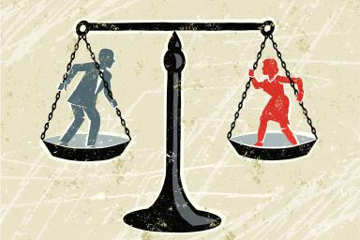
– Since women can reason, they should have the same rights as men
– Founder _______________________________

