- Fajitas
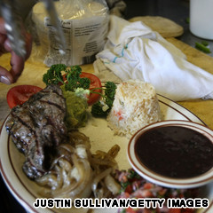
Yep, this is real American food.
Take some vaqueros working on the range and the cattle slaughtered to feed them. Throw in the throwaway cuts of meat as part of the hands’ take-home pay, and let cowboy ingenuity go to work.
Grill skirt steak (faja in Spanish) over the campfire, wrap in a tortilla, and you’ve got the beginning of a Rio Grande region tradition. The fajita is thought to have come off the range and into popular culture when a certain Sonny Falcon began operating fajita taco stands at outdoor events and rodeos in Texas beginning in 1969.
It wasn’t long before the dish was making its way onto menus in the Lone Star State and spreading with its beloved array of condiments -- grilled onions and green pepper, pico de gallo, shredded cheese, and sour cream -- across the country. Don’t forget the Altoids.

Include this in your poster:

What is your dish?

What are the main ingredients?

Where does each ingredient come from in terms of the Columbian Exchange?

Draw an image of your product.

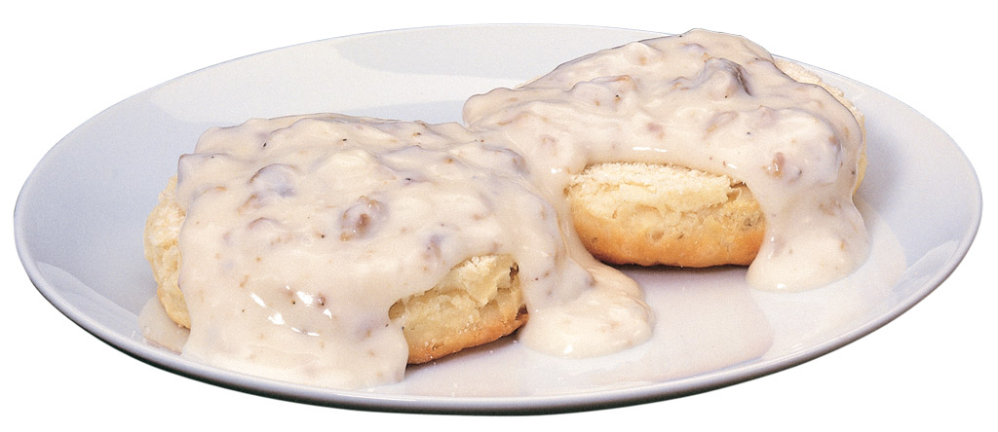

Biscuits ’n’ gravy
An irresistible Southern favorite, biscuits and gravy would be a cliché if they weren’t so darned delicious.
The biscuits are traditionally made with butter or lard and buttermilk; the milk (or “sawmill” or country) gravy with meat drippings and (usually) chunks of good fresh pork sausage and black pepper.
Cheap and requiring only widely available ingredients, a meal of biscuits and gravy was a filling way for slaves and sharecroppers to face a hard day in the fields.
“The Southern way with gravies was born of privation. When folks are poor, they make do. Which means folks make gravy,” says The Southern Foodways Alliance Community Cookbook. The soul, you might say, of soul food.

Include this in your poster:

What is your dish?

What are the main ingredients?

Where does each ingredient come from in terms of the Columbian Exchange?

Draw an image of your product.

Fried chicken and waffles

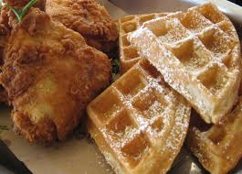
Scottish immigrants brought the deep-fry method across the pond, and it was good old Colonel Saunders who really locked in on the commercial potential in 1930 when he started pressure-frying chicken breaded in his secret spices at his service station in Corbin, Kentucky, paving the way for Kentucky Fried and all the other fried chickens to come.
Nuggets, fingers, popcorn, bites, patties -- one of our all-time favorite ways to eat fried chicken is with waffles. And one of our favorite places to eat it is at Roscoe’s Chicken and Waffles.
Immortalized in "Pulp Fiction" and "Swingers," the L.A. institution got the soul-food seal of approval when Obama himself related to Jay Leno on "The Tonight Show" that he’d popped in for some wings and waffles and downed them in the presidential limo.

Include this in your poster:

What is your dish?

What are the main ingredients?

Where does each ingredient come from in terms of the Columbian Exchange?

Draw an image of your product.

S’mores
S'mores on frozen hot chocolate.
Proust’s madeleines? We’ll go you one better on remembrance of things past: s’mores.
Gooey, melty, warm and sweet -- nothing evokes family vacations and carefree camping under the stars quite like this classic American food.
Whether they were first to roast marshmallows and squish them between graham crackers with a bar of chocolate no one seems to know, but the Girl Scouts were the first to get the recipe down in the 1927 "Tramping and Trailing with the Girl Scouts," transforming many a standard-issue campfire into a quintessential experience.
Celebrate sweetly on August 10: It’s National S’mores Day. Get those marshmallow sticks sharpened.

Include this in your poster:

What is your dish?

What are the main ingredients?

Where does each ingredient come from in terms of the Columbian Exchange?

Draw an image of your product.

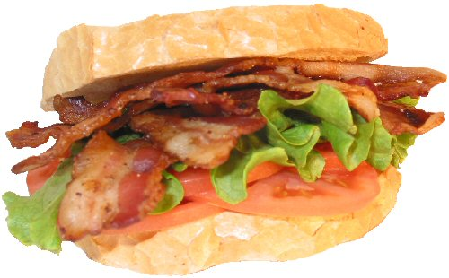

BLT
How many sandwiches get to go by their initials?
When tomatoes come into season, there’s hardly a better way to celebrate the bounty than with a juicy bacon, lettuce, and tomato.
Food guru John Mariani says the BLT is the no. 2 favorite sandwich in the United States (after ham), and it’s no. 1 in the United Kingdom.
Bread can be toasted or un, bacon crispy or limp, lettuce iceberg or other (but iceberg is preferred for imparting crunch and no interfering flavor), and mayo good quality or just forget about it.
Provenance of the BLT isn’t clear, but a remarkably similar club sandwich showed up in the 1903 Good Housekeeping Everyday Cook Book. Even if the sodium level gives the health-minded pause, the BLT tastes like summer -- and who can resist that?

Include this in your poster:

What is your dish?

What are the main ingredients?

Where does each ingredient come from in terms of the Columbian Exchange?

Draw an image of your product.

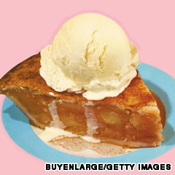
Apple pie

According to a pie chart (seriously) from the American Pie Council, apple really is our national favorite -- followed by pumpkin, chocolate, lemon meringue and cherry.
Not to burst the patriotic bubble, but it’s not an American food of indigenous origin.
Food critic John Mariani dates the appearance of apple pies in the United States to 1780, long after they were popular in England. Apples aren’t even native to the continent; the Pilgrims brought seeds.
So what’s the deal with the star-spangled association? The pie council’s John Lehndorff explains: “When you say that something is ‘as American as apple pie,’ what you're really saying is that the item came to this country from elsewhere and was transformed into a distinctly American experience.”
And you’re saying Americans know something good enough to be an icon when we eat it, with or without the cheddar cheese or vanilla ice cream on top.

Include this in your poster:

What is your dish?

What are the main ingredients?

Where does each ingredient come from in terms of the Columbian Exchange?

Draw an image of your product.

7. Chocolate-chip cookies
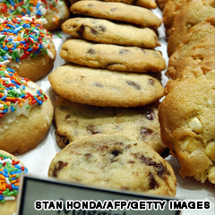
Chew-crunchy, yummy perfection.
Today the name most associated with the killer cookie might be Mrs. Fields, but we actually have Ruth Wakefield, who owned the Toll House Inn, a popular spot for home cooking in 1930s Whitman, Massachusetts, to thank for all spoon-licking love shared through chocolate chip cookies.
Was Mrs. Wakefield making her Butter Drop Do cookies when, lacking baker’s chocolate, she substituted a cut-up Nestle’s semisweet chocolate bar? Or did the vibrations of a Hobart mixer knock some chocolate bars off a shelf and into her sugar-cookie dough?
However chocolate chips ended up in the batter, a new cookie was born. Andrew Nestle reputedly got the recipe from her -- it remains on the package to this day -- and Wakefield got a lifetime supply of chocolate chips. Can you feel the serotonin and endorphins releasing?

Include this in your poster:

What is your dish?

What are the main ingredients?

Where does each ingredient come from in terms of the Columbian Exchange?

Draw an image of your product.

Chicago-style pizza

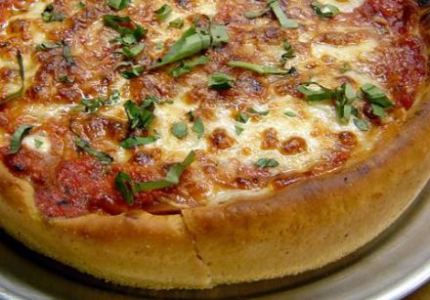
Naples gave us the first pizza, but the City of Big Shoulders (and even bigger pizzas) gave us the deep dish. The legend goes that in 1943, a visionary named Ike Sewell opened Uno’s Pizzeria in Chicago with the idea that if you made it hearty enough, pizza, which up till then had been considered a snack, could be eaten as a meal.
Whether he or his original chef Rudy Malnati originated it, one of those patron saints of pizza made it deep and piled it high, filling a tall buttery crust with lots of meat, cheese, tomato chunks, and authentic Italian spices.
Thin-crust pizza made in a brick oven has its place, but if you lust for crust, nothing satisfies quite like Chicago-style.

Include this in your poster:

What is your dish?

What are the main ingredients?

Where does each ingredient come from in terms of the Columbian Exchange?

Draw an image of your product.

