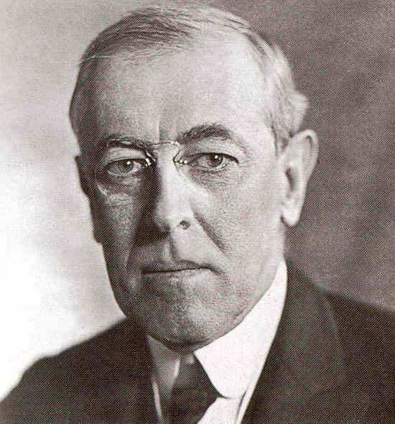
Leading up to Wilson's Speech
The United States entered World War I on the side of the Allies on April 6, 1917. However, the U.S. entered the war reluctantly. Unlike many European nations, the U.S. wasn't fighting over territory or in revenge for past wars. Wilson wanted the end of the war to bring out lasting peace for the world. He gathered together a number of advisors and had them put together a plan for peace. This plan became the Fourteen Points.
Purpose of the Fourteen Points
The main purpose of the Fourteen Points was to outline a strategy for ending the war. He set out specific goals that he wanted to achieve through the war. If the United States was going to fight in Europe and soldiers were going to lose their lives, he wanted to establish exactly what they were fighting for. Through this speech and the Fourteen Points, Wilson became the only leader of the countries fighting in the war to publicly outline his war goals.

The Fourteen Points

- No more secret agreements between countries. Diplomacy shall be open to the world.

- International seas shall be free to navigate during peace and war.

- There shall be free trade between the countries who accept the peace.

- There shall be a worldwide reduction in weapons and armies by all countries.

- Colonial claims over land and regions will be fair.

- Russia will be allowed to determine its own form of government. All German troops will leave Russian soil.

- German troops will evacuate Belgium and Belgium will be an independent country.

- France will regain all territory including the disputed land of Alsace-Lorraine.

- The borders of Italy will be established such that all Italians will be within the country of Italy.

- Austria-Hungary will be allowed to continue to be an independent country.

- The Central Powers will evacuate Serbia, Montenegro, and Romania leaving them as independent countries.

- The Turkish people of the Ottoman Empire will have their own country. Other nationalities under the Ottoman rule will also have security.

- Poland shall be an independent country.

- A League of Nations will be formed that protects the independence of all countries no matter how big or small.

What did other leaders think?
The leaders of the other Allied Nations, including David Lloyd George of Britain and Georges Clemenceau of France, thought that Wilson was being too idealistic. They were skeptical as to whether these points could be accomplished in the real world. Clemenceau of France, in particular, did not agree with Wilson's plan for "peace without blame" for Germany. He fought for, and got, harsh reparation penalties against Germany.

Activity: The Fourteen Points
Student Name _____________________________________________ Date ________________
Four major goals of Wilsonian Foreign Policy
- Spreading democracy: the citizens of other nations should have the freedom to choose representative or democratic government. Wilson believed that the United States should help other nations create democratic governments for themselves, if they were not already democratic.

Which of the 14 Points show this goal?

- Open markets: nations should work to lower barriers to free trade among themselves. By lowering or ending tariffs and duties on imported goods, nations could expect trading partners to do the same, thus benefiting all. Wilson regarded open markets as an essential part of capitalism and democracy.

Which of the 14 Points show this goal?

- International organization dedicated to keeping peace: by joining together and promising to protect each other, democratic nations could deter wars of aggression and conquest. Ideally, a powerful nation would think twice about attacking a smaller nation if it was a member of this international organization. This concept is known as “international collective security” and served as the basis for the League of Nations. Wilson, who believed that democratic nations were inherently peaceful (meaning they did not start wars), also hoped the League of Nations could promoted self-determination across the world.

Which of the 14 Points show this goal?

- Active global role for the United States: in order to achieve his first three goals, Wilson recognized that his nation needed to act as a leader in world affairs and use its power and influence to persuade, even force, other nations to accept these goals and work with the U.S. to fulfill them. For this reason, Wilson had offered to mediate an end to the war in January 1917, in his “Peace without Victory” address (http://www.lib.byu.edu/~rdh/wwi/1917/senate.html).

Which of the 14 Points show this goal?

