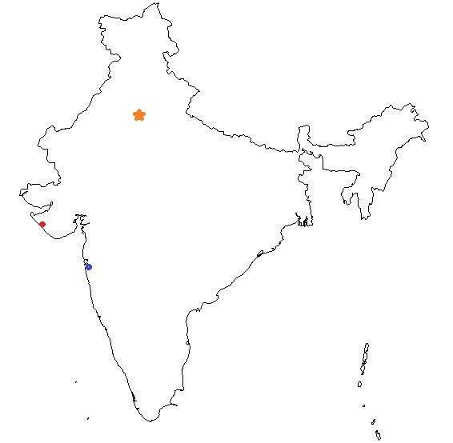

Gandhi

Gandhi was born in Porbandar, India in 1869. On the map locate Porbandar, New Delhi and
Bombay (now called Mumbai).

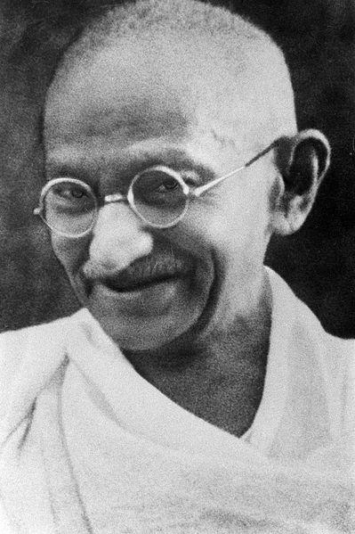
Gandhi was the of six children.

When Gandhi was years old he married Kasturbai
Makanji. Their marriage lasted for years.

Gandhi went to to study law when he was _.

Instead of wearing an Indian turban and loose-fitting clothes, he wore .

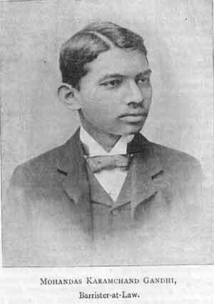
After he got his law degree, he returned to India and began practicing law in .

Just a couple of years later, he was asked to represent an Indian company in a civil law suit in .

While he was there, he bought a first class ticket to Pretoria. But, he was not allowed to sit in the seat he purchased. He was told to sit in the
_ car. He refused and was kicked off the train.

After that, Gandhi resolved to fight back . Life was harsh for both Indians and blacks. For example, Indians and blacks could be arrested for walking on the same as whites.

South Africa tried to stop Indian immigration and law makers wanted to deny
Indians the right to . Gandhi took up their cause.

As news spread, world opinion pressured the British colonial Office to say that every citizen of the British Empire had the right to and the right to anywhere in the empire. Unfortunately, white law makers in South Africa overruled the Colonial Office. Gandhi lead the fight against these unjust laws, protesting and leading marches against the government. In 1914 South Africa passed the Indian Relief Act which put an end to most of these laws.

Gandhi remained in South Africa for years, but after the outbreak of
WWI, he returned to . He called for Indians to help England win the war. After the war ended, Gandhi called for independence. Great Britain passed censorship laws, banned of assembly and even Gandhi's .

Gandhi called for a nonviolent strike. "Nonviolence," he said, "is a weapon for the
." Still, violence did occur. nearly 15,000 people
held an illegal meeting in Amritsar. The British fired on the crowd and many people died.

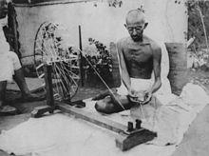
Gandhi encouraged Indians to grow their own
and to spin their own . In 1930 Gandhi led a
to the to protest the
British tax on .

During WWII, Gandhi demanded independence. He called for civil
. He and many of his followers were jailed for
. While Gandhi was in prison there were many .

In 1946, England proposed _ for India. Some Indian Muslims wanted their own country.
, a Muslim state, was carved
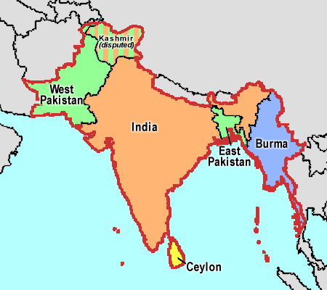
out of West and East India. Some Hindus were bitter that Gandhi had reconciled with the Muslims. In January 1948 Gandhi was assassinated by an angry Hindu.

