Causes of the Scientific Revolution

• Before_________________________________________________________________
_______________________________________________________________________.
• The Renaissance’s rebirth in learning inspired curiosity in many fields.
- Reformation prompted followers to challenge accepted ways of thinking about God.
- By the mid-1500s, scholars begin to challenge the ideas of ancient thinkers and the church.
- Scientific ______________________________________________________________
______________________________________________________________________.

Causes of the Scientific Revolution
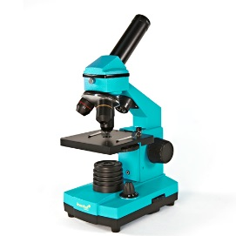
•New _____________________________________________________________________
_________________________________________________________________________.
– Telescope, microscope, printing press, chronometer
• Mathematics played a key role in the achievements during the 1600-1700s
– Francois Viete – used letters to represent unknown quantities and laid the foundation.
for trigonometry
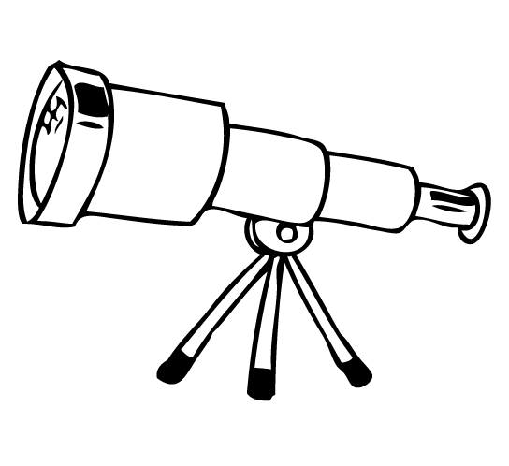
– Simon Stevin – introduced the decimal system
– John Napier – invented a table of logarithms, making calculations much easier

• Ancient ___________________________________________________________________
___________________________________________________________________________.
– The rediscovery of their works made proving abstract theories with clear logical evidence
(algebra, geometry, trigonometry) much easier.

Ptolemaic System

•An early challenge to accepted scientific thought came in the field of astronomy
• Ptolemy (100s), the greatest ancient astronomer, in addition to Aristotle and Christianity, _________
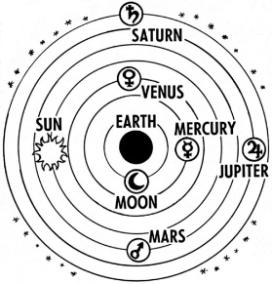
____________________________________________________________________________________.
– Is a series of concentric circles where the heavenly bodies are embedded in crystal-like,
transparent spheres.
– The moon is embedded in the first sphere, Mercury the second, Venus the third, and the Sun
in the fourth.
– The tenth sphere is the “prime mover” that gives motion to the other spheres. – Beyond the
prime mover is Heaven and God
• God at one end and humans at the center.

Copernicus and Kepler

•1543: mathematician Nicolaus Copernicus publishes a heliocentric conception of the universe.
– His _______________________________________________________________________.
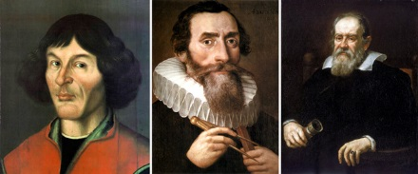
• German __________________________________________________________________________.
– Discovered elliptical orbits, which contradicted the Ptolemaic System
– Confirmed the heliocentric view of Copernicus using mathematical data

Galileo’s Discoveries

• Galileo Galilei: _____________________________________________________________________
__________________________________________________________________________________.
– Mountains on Earth’s moon, four moons around Jupiter, and sunspots
– 1610 – Published The Starry Messenger
• His observations continued to destroy the Ptolemaic system.
• Ordered __________________________________________________________________________.
– Threatened the Church’s view of the universe with humans not center and no scientific God

Newton’s View of the Universe
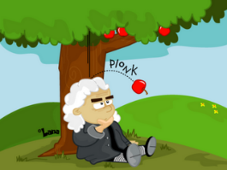
• Newton’s ideas would tie together those of Copernicus, Kepler, and Galileo.
• Professor of Mathematics at Cambridge University
• Wrote Mathematical Principles of Natural Philosophy (Principia)
• Defined ___________________________________________________________________________.
– States in mathematical terms that objects in the universe are attracted to every other objet
by gravity
– His laws could explain all motion in the universe

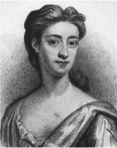
Women’s Contributions

• ______________________________
– English aristocrat who was homeschooled, she studied “suitable” subjects (music, dance,
needlepoint)
– Wrote on a number of scientific matters.
• Question the belief of humans, through science, as masters of the universe.
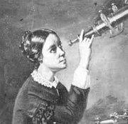
– Published under her own name, but not taken seriously at the time.
• ______________________________
– German astronomer who married Prussia’ s foremost astronomer.
– as his assistant she made some original discoveries such as a comet.
– Denied a position as assistant astronomer at Berlin Academy.
– “Mouths would gape” if the Academy hired a woman scientist.

Bacon and the Scientific Method
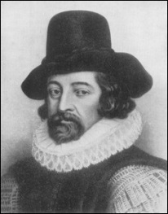
• To understand the physical world, the ___________________________________ was created.
– Systematic procedure for collecting and analyzing evidence.
• Francis Bacon believed in using __________________ to learn about nature – not ancient authorities.
• “the true and lawful goal of the sciences is none other than this: that human life be endowed with new discoveries and power”
• He wanted science to benefit industry, agriculture and trade
• Bacon believed humans could “________________________________”

