Use the timeline below to answer the questions.
Reading a Timeline
Name:

Answers

Lewis and Clark’s Expedition
1.
Lewis and Clark return home and are national heroes
Sep 1806

1803

Louisiana Purchase Jul 1803

1804

Lewis and Clark’s expedition begins May 1804
Sacagawea has a baby boy, Jean Baptiste
Feb 1805
Clark thinks he sees the Pacific Ocean
Nov 1805

1805 1806

Lewis and Clark see a grizzly bear for the first time Aug 1805
Lewis and Clark meet a fur trapper named Charbonneau and his wife Sacagawea Nov 1804

Blackfeet Indians try to steal some rifles
Jul 1806

1807

2.

3.

4.

5.

6.

7.

- Which happened earlier? A. Indians try to steal rifles or B. Lewis and Clark see a grizzly bear

- What year was the Louisiana Purchase?

- How many years did Lewis and Clark’s expedition take?

- What year did Sacagawea have her child?
08.

9.

10.

Use line on worksheet
Use line on worksheet

- What is the span (number of years shown) of this timeline?

- What year did Lewis and Clark meet Charbonneau?

- What year did Lewis and Clark return home?

- In September of 1804 Lewis and Clark saw a prairie dog. Could you put this event on the timeline above? ( Yes / No )

- What event happened in Nov 1805?

- What is this timeline about?

1-10 90 80 70 60 50 40 30 20 10 0

Social Studies

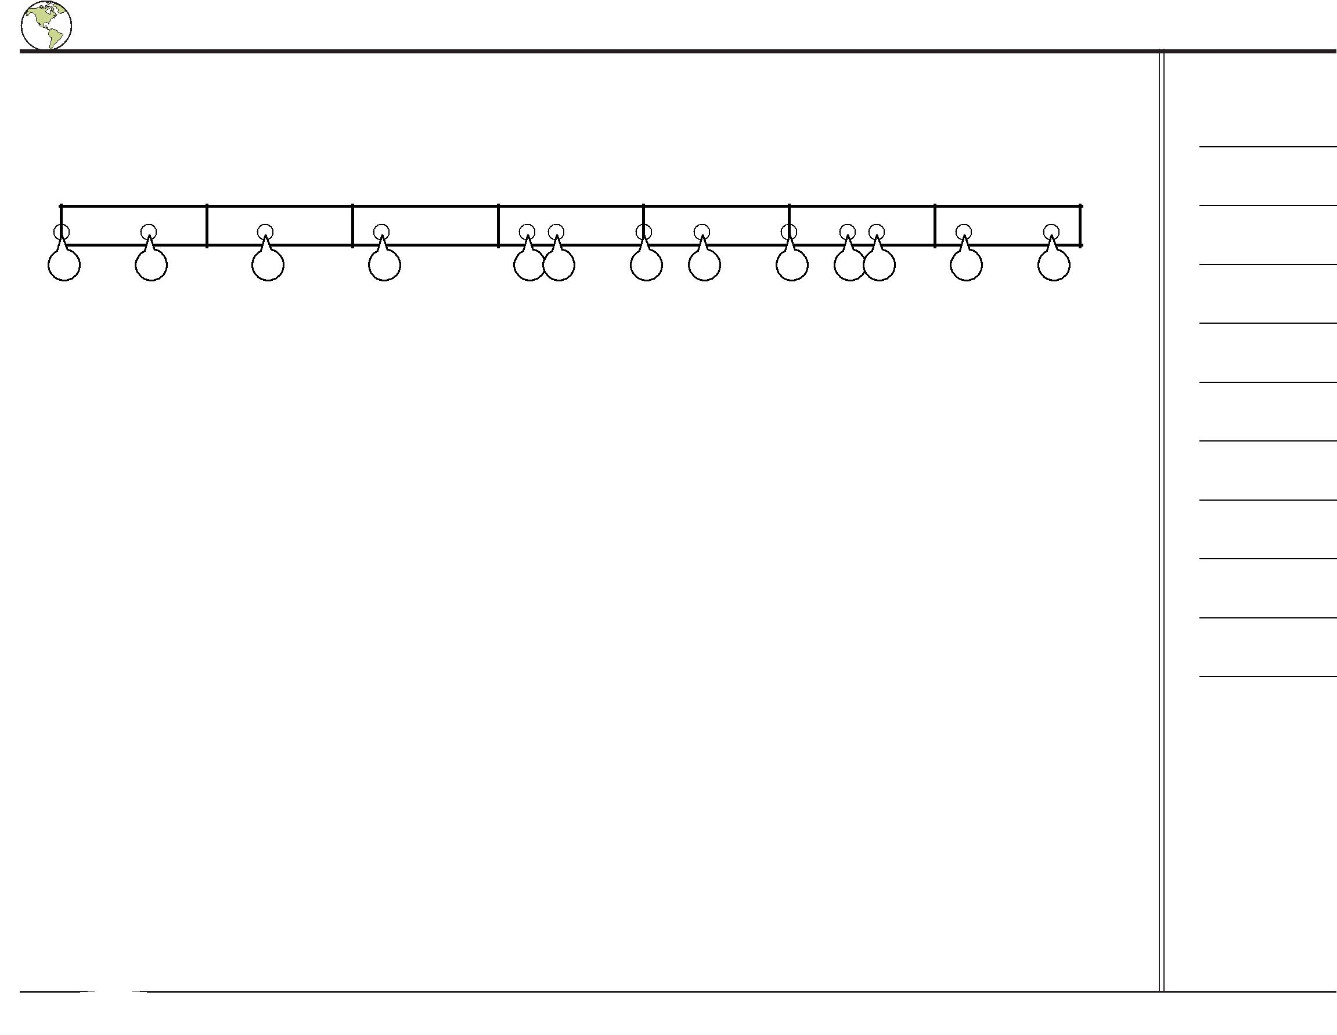
Placing Events on a Timeline ^{Name:}

Determine which letter best represents the location the event should occur on the timeline. Not all letters will be used.

Early Milestones in Cinema

1875 |  | 1880 | 1885 | 1890 |  | 1895 | 1900 |  | 1905 | 1910
A | B | C |  | D | E F | G H | I | J K | L | M

- Harvey Wilcox's wife, Daeida, names her ranch in California, 'Hollywood'. (1886)

- \‘The Great Train Robbery' is one of the first western films. It is 12 minutes long. (1903)

- The first video camera is created by Etienne Marey. It takes 12 images per second. (1882)

- The first motion picture is projected onto a screen for paying audiences (An 8 minute boxing match) . (1895)

- The Limelight Department becomes one of the first feature film studios. (1892)

- Special effects are introduced by Georges Méliès in the film, 'Le Voyage Dans La Lune'. (1902)

Answers

1.

2.

3.

4.

5.

6.

7.

8.

9.

10.

- The first camera is introduced by 'The Eastman Kodak Company'. It costs $1. (1900)

- British Photograph Eaweard Muybridge takes multiple photographs in sequence creating the first video. (1878)

- \‘Humorous Phases of Funny Faces' is one of the earliest animated films. (1906)

- 35 mm width film becomes the standard for motion pictures. (1897)

Social Studies |  |  | 1-10 | 90 | 80 | 70 | 60 | 50 | 40 | 30 | 20 | 10 | 0

