Key Terms: Know the Definitions
- Circumnavigation
- New World
- Old World
- Hispaniola
- Effect
- Native
- Spaniard
- Enormous
- Labor
- Timid

- What motivated the Europeans to begin to find water routes to Asia?

- Which explorer is given credit for circumnavigating the globe?

- List the reasons why Europeans wanted to explore?

- Who might consider Columbus a villain? Why?

- Who might consider Columbus a hero? Why?

- Which explorer found a water route to Asia?

- Which group of people were converted to Christianity and overworked in gold mines?

- Who explored the regions of the world circled below?
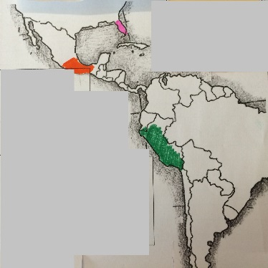

Key Terms: Know the Definitions
- Circumnavigation
- New World
- Old World
- Hispaniola
- Effect
- Native
- Spaniard
- Enormous
- Labor
- Timid

- What motivated the Europeans to begin to find water routes to Asia?

- Which explorer is given credit for circumnavigating the globe?

- List the reasons why Europeans wanted to explore?

- Who might consider Columbus a villain? Why?

- Who might consider Columbus a hero? Why?

- Which explorer found a water route to Asia?

- Which group of people were converted to Christianity and overworked in gold mines?

- Who explored the regions of the world circled below?

