Key Terms: Know the Definitions
- Atlantic Slave Trade
- Globalization
- Colonization
- Middle Passage
- Columbian Exchange
- Indigenous
- Conquistador
- Encomienda
- Missionaries
- Exploitation

- What caused the massive decrease in the Native American population?

- How did the Columbian Exchange effect the Africans?

- How did the Columbian Exchange lead to globalization?

- What effect did the Columbian Exchange have on European countries?

- What effect did the Columbian Exchange have on the Native Americans?

- List the motives that Europeans had to colonize the “New World”.

- Describe the Middle Passage journey.

- What is being shown in the image below?
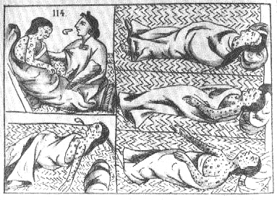

Key Terms: Know the Definitions
- Atlantic Slave Trade
- Globalization
- Colonization
- Middle Passage
- Columbian Exchange
- Indigenous
- Conquistador
- Encomienda
- Missionaries
- Exploitation

- What caused the massive decrease in the Native American population?

- How did the Columbian Exchange effect the Africans?

- How did the Columbian Exchange lead to globalization?

- What effect did the Columbian Exchange have on European countries?

- What effect did the Columbian Exchange have on the Native Americans?

- List the motives that Europeans had to colonize the “New World”.

- Describe the Middle Passage journey.

- What is being shown in the image below?

