Key Terms: Know the Definitions
- Imperialism
- Nationalism
- Militarism
- Alliances
- Trench Warfare
- Casualties
- League of Nations
- Fourteen Points
- Tsar
- Propaganda

- List as many items of new technology used in WW1.

- Name the two WW1 alliances and their respective countries.

- Why was WW1 nicknamed “The War to End All Wars”?

- Describe ‘Communism’.

- Describe how Germany was treated at the Treaty of Versailles?

- What were some causes of the Russian Revolution?

- What is the purpose of the following image? How is it supposed to make one feel?

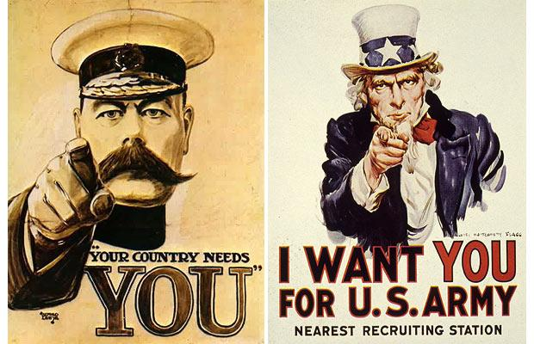

Key Terms: Know the Definitions
- Imperialism
- Nationalism
- Militarism
- Alliances
- Trench Warfare
- Casualties
- League of Nations
- Fourteen Points
- Tsar
- Propaganda

- List as many items of new technology used in WW1.

- Name the two WW1 alliances and their respective countries.

- Why was WW1 nicknamed “The War to End All Wars”?

- Describe ‘Communism’.

- Describe how Germany was treated at the Treaty of Versailles?

- What were some causes of the Russian Revolution?

- What is the purpose of the following image? How is it supposed to make one feel?

