Key Terms: Know the Definitions
- Marshall Plan
- NATO
- Cold War
- Containment
- Domino Theory
- Ballistic Missile
- Detente
- Proposal
- Haste
- Objective

- Why did the US send troops to Korea?

“From Stetin in the Baltic to Trieste in the Adriatic, an Iron Curtain has descended across the continent. Behind that line lie all the capitals of the ancient states of Central and Eastern Europe. Warsaw, Berlin, Prague, Vienna, Budapest, Belgrade, Bucharest and Sofia, all these famous cities and the populations around them lie in what I might call the Soviet Sphere, and all are subject, in one form or another, not only to Soviet influence, but to very high, and in some cases increasing measure of control from Moscow."

-Winston Churchill

- What is the main idea of this quotation?

- Which countries became Cold War “battlegrounds”?

- Name the countries that would become Communist.

- List some of the Containment policies.

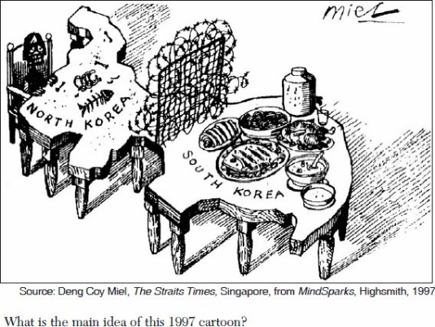

- Compare and contrast the two sides.

Key Terms: Know the Definitions
- Marshall Plan
- NATO
- Cold War
- Containment
- Domino Theory
- Ballistic Missile
- Detente
- Proposal
- Haste
- Objective

- Why did the US send troops to Korea?

“From Stetin in the Baltic to Trieste in the Adriatic, an Iron Curtain has descended across the continent. Behind that line lie all the capitals of the ancient states of Central and Eastern Europe. Warsaw, Berlin, Prague, Vienna, Budapest, Belgrade, Bucharest and Sofia, all these famous cities and the populations around them lie in what I might call the Soviet Sphere, and all are subject, in one form or another, not only to Soviet influence, but to very high, and in some cases increasing measure of control from Moscow."

-Winston Churchill

- What is the main idea of this quotation?

- Which countries became Cold War “battlegrounds”?

- Name the countries that would become Communist.

- List some of the Containment policies.

- Compare and contrast the two sides.

